The steps to set up this tool on an Ubuntu 18.04.03 are as follows:
Installing python
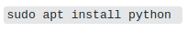

Updating and upgrading ubuntu
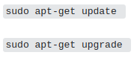

Installing GNU-radio
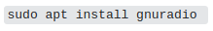

Downloading wireshark-1.12.0 from

Installing mercurial

Installing gr-osmosdr

Installing hackrf
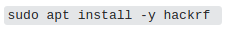

Clone EZ-wave from Github
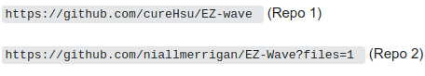

Extract EZ-wave from repo 1
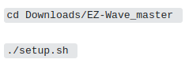

Going in scapy-radio
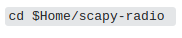

Installing the following dependencies for scapy-radio
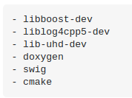

Installing Scapy-Radio
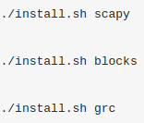

The grc installation gave a validation error at the end which took me a lot of time to solve.
The trick to fix this error was to go to the Zwave.grc file located in

and set the value for
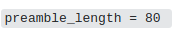

The next step in setting up this tool was to install wireshark with wireshark dissector. The files provided in the repo 1 was giving errors to bulid the wireshark.So the wireshark dissectors files from repo 2 were used.(Only using Repo 2 was giving errors to install scapy)
Dependencies to be installed
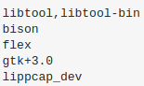

once the dependencies were installed, the steps showed on the website
http://oldsmokingjoe.blogspot.com/2016/04/z-wave-protocol-analysis-using-ez-wave.html
were used to install the wireshark.

